

Air University, Islamabad

Full-Stack Lab # 02
19/09/2026

Submitted By:
Student Name: Muhammad Ahmad Shafique
Student ID: 241829
Class: BSCS-V-C
Submitted To:
Instructor Name: Mam Fizza Asmat

Note: All the code Files for the below Screenshots are properly Maintained and Saved in the GitHub Repo. The Link to which is also shared on GCR.
Account Registration Form
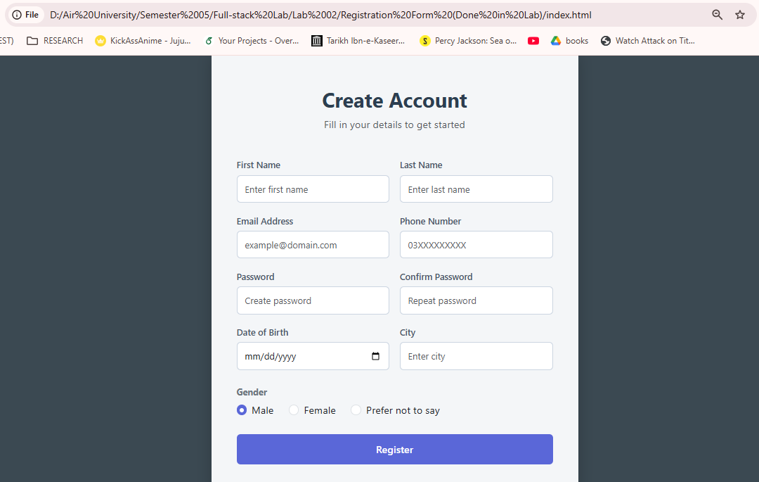
(Done in Lab)

Team Showcase Dashboard
Made in Lab Alongside Mam:
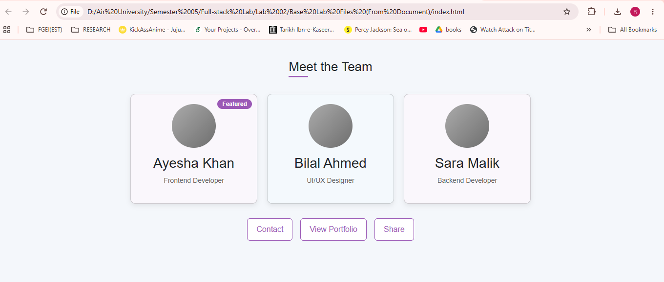
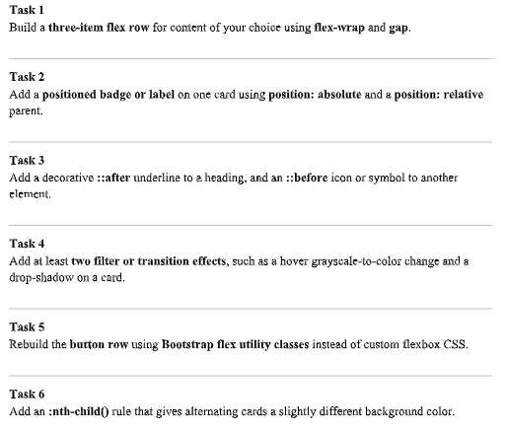
Lab Tasks 1 – 6

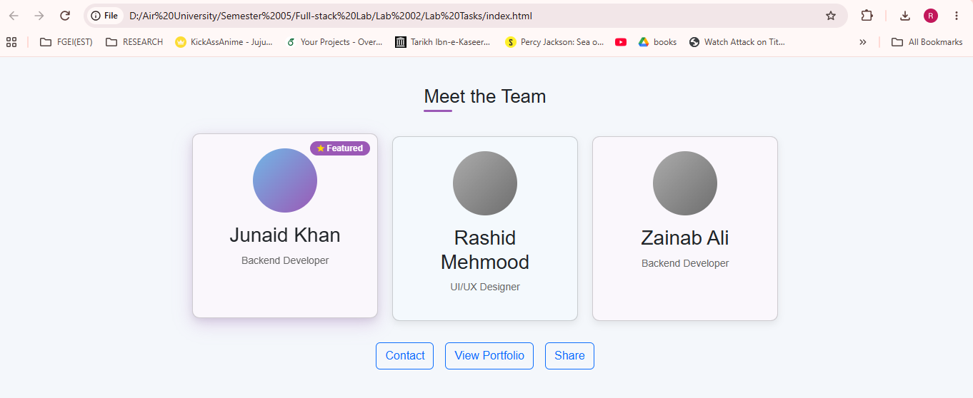
Screenshot of the Output:
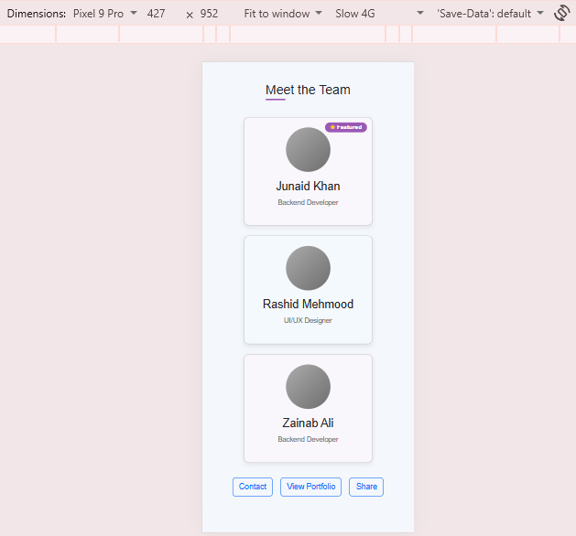
Mobile View:

Dashboard Making Task
Screenshot of the Dashboard Made:
